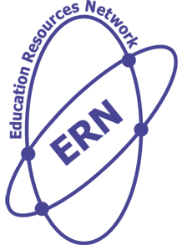
Education Resources Network
Documents | Yes | No | Pending
Copies of all transcripts and degrees of qualifications completed or latest transcript if qualification is under process.

A Level subject list (if A level result is pending)

Passport copy along with the signed page
Copies of all previous and current TIER 4 UK Student visas and CAS Statements (If you have studied in the UK before)

Previous visa refusal letter (If any)

CV (Compulsory only for Postgraduate applicants)

Personal statement (300-500 words for UCAS up to 4,000 characters including spaces)
Points to cover the Personal Statement:
  - Your academic background.
  - Academic and non-academic achievements
  - Volunteer work
  - Reasons of want to study the proposed course
  - Why the UK
  - Future plans.
Proposed Length 1.5 – 2 Pages (Ariel 10 Font)
PG Students: Recommendation letters on the Institutes letterhead. If you have completed your studies more than 3 years ago, than one recommendation from your previous Institute and one from the current employer. Recommendation letters, but must be signed stamped and on the letterhead including the referee’s email addresses. If letters are not possible please provide: Name, email and contact No of any two teachers at your Previous Institute who can write you a recommendation or if you have been working for more than a year than 1 teacher reference and 1 current employer reference.

UG Students applying via UCAS: Name and official Institute email address of one teacher or counsellor. If it’s a teacher, we need to know the subject they taught you or are teaching you currently.

Document Checklist

